|  |  |  |  |  |
| --- | --- | --- | --- | --- |
| **Class**  <chr> | **Frequency_of_Class**  <int> | **Recommended_Students**  <int> |  |  |
| 2021 | 84 | 72 |  |  |
| 2022 | 84 | 75 |  |  |
| 2020 | 57 | 56 |  |  |
| 2023 | 48 | 45 |  |  |
| 2024 | 15 | 13 |  |  |
| Grad | 1 | 1 |  |  |

| **School**  <chr> | **Frequency**  <int> | **Recommended_Students1**  <int> |  |  |
| --- | --- | --- | --- | --- |
| Bloustein | 1 | 1 |  |  |
| EMSOP | 12 | 10 |  |  |
| MGSA | 7 | 6 |  |  |
| N/A | 1 | 0 |  |  |
| Nursing | 2 | 2 |  |  |
| RBS | 19 | 16 |  |  |
| SAS | 196 | 179 |  |  |
| SOE | 22 | 20 |  |  |
| SEBS | 31 | 29 |  |  |

|  |  |  |  |  |
| --- | --- | --- | --- | --- |
| **DACA_Label**  <chr> | **DACA_req_freq**  <int> | **DACA_recom_frq**  <int> |  |  |
| YES | 19 | 19 |  |  |
| NO | 248 | 232 |  |  |
| N/A | 25 | 13 |  |  |

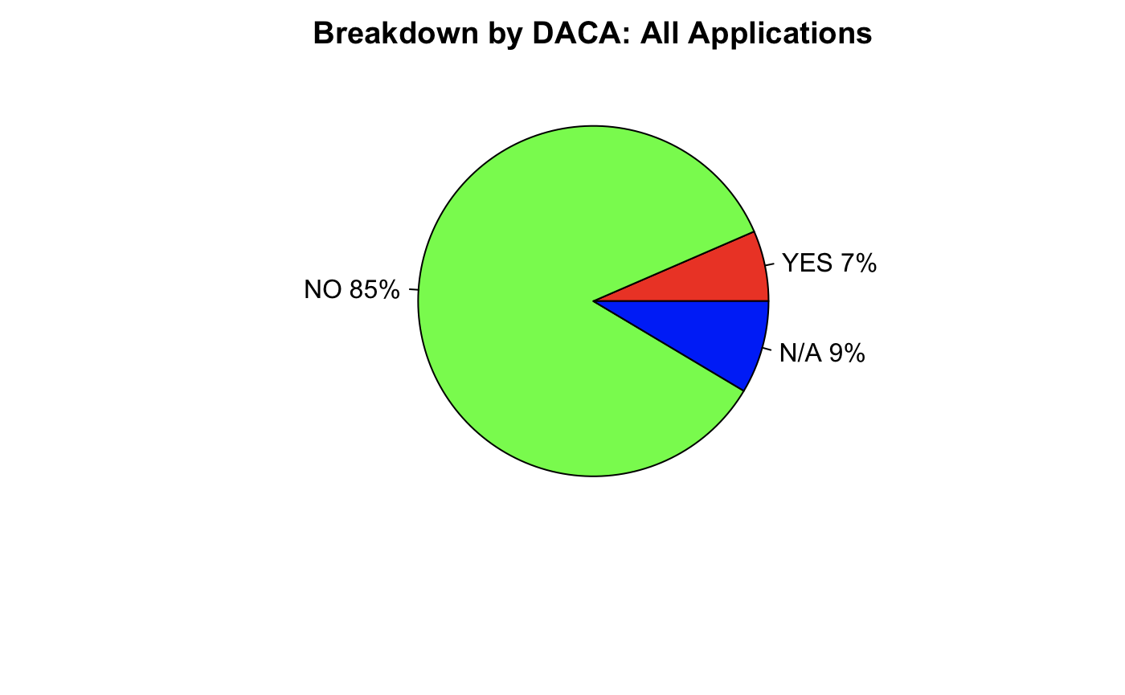

|  |  |  |  |  |
| --- | --- | --- | --- | --- |
| **International_Label**  <chr> | **International_req_freq**  <int> | **International_recom_frq**  <int> |  |  |
| YES | 14 | 14 |  |  |
| NO | 252 | 236 |  |  |
| N/A | 26 | 14 |  |  |

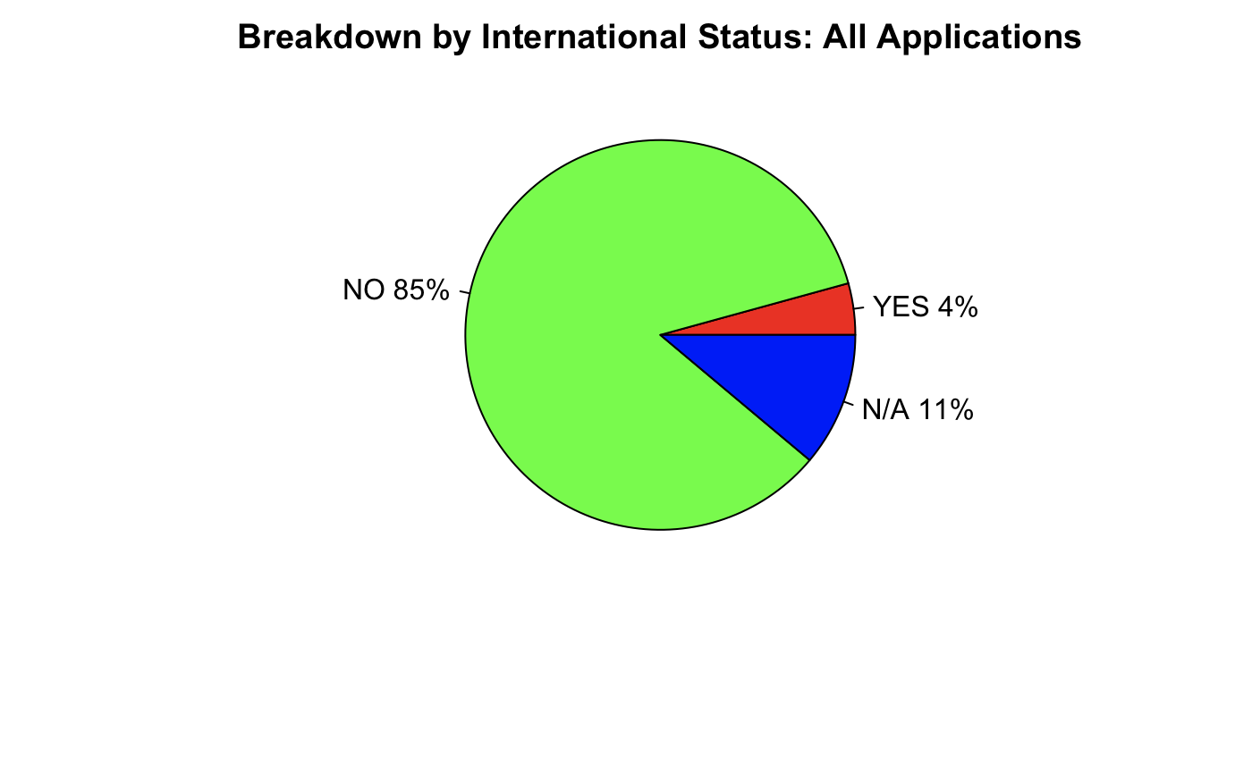

| **FI_Label**  <chr> | **FI_req_freq**  <int> | **FI_recom_frq**  <int> |  |  |
| --- | --- | --- | --- | --- |
| YES | 102 | 99 |  |  |
| NO | 164 | 149 |  |  |
| N/A | 26 | 16 |  |  |

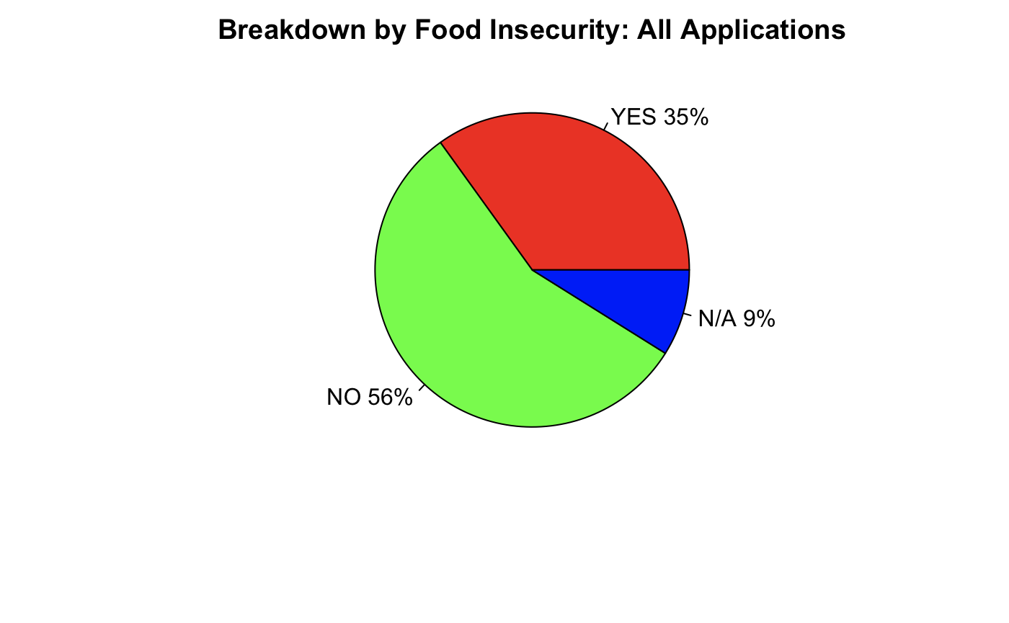

|  |  |  |  |  |
| --- | --- | --- | --- | --- |
| **Requested_Food_Label**  <chr> | **Requested_Food_req_freq**  <int> | **Requested_Food_recom_frq**  <int> |  |  |
| YES | 244 | 233 |  |  |
| NO | 48 | 31 |  |  |
| N/A | 0 | 0 |  |  |

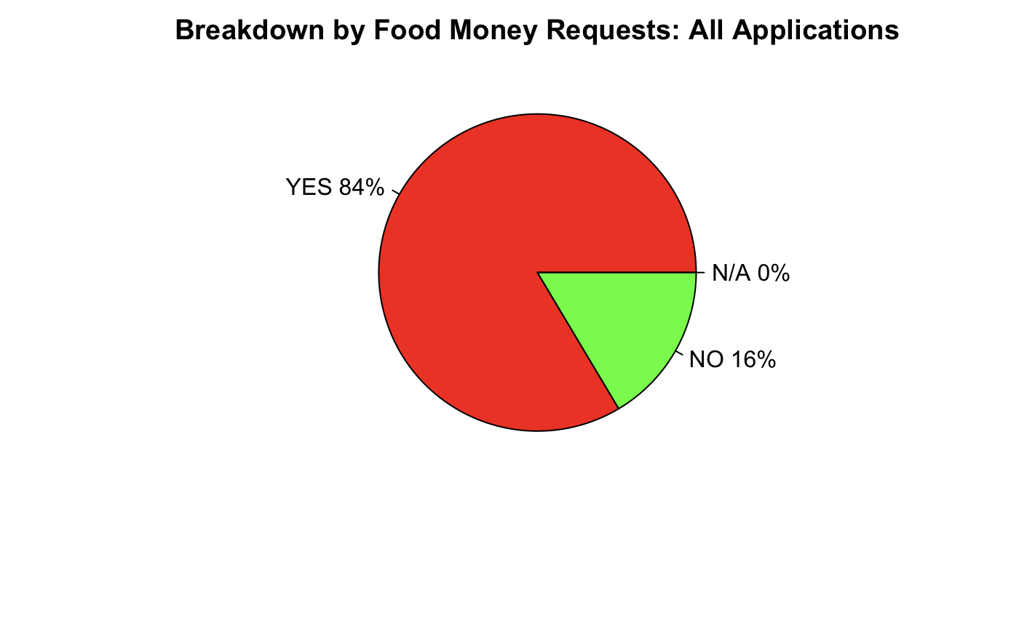

|  |  |  |  |  |
| --- | --- | --- | --- | --- |
| **Requested_Rent_Label**  <chr> | **Requested_Rent_req_freq**  <int> | **Requested_Rent_recom_frq**  <int> |  |  |
| YES | 131 | 122 |  |  |
| NO | 161 | 142 |  |  |
| N/A | 0 | 0 |  |  |

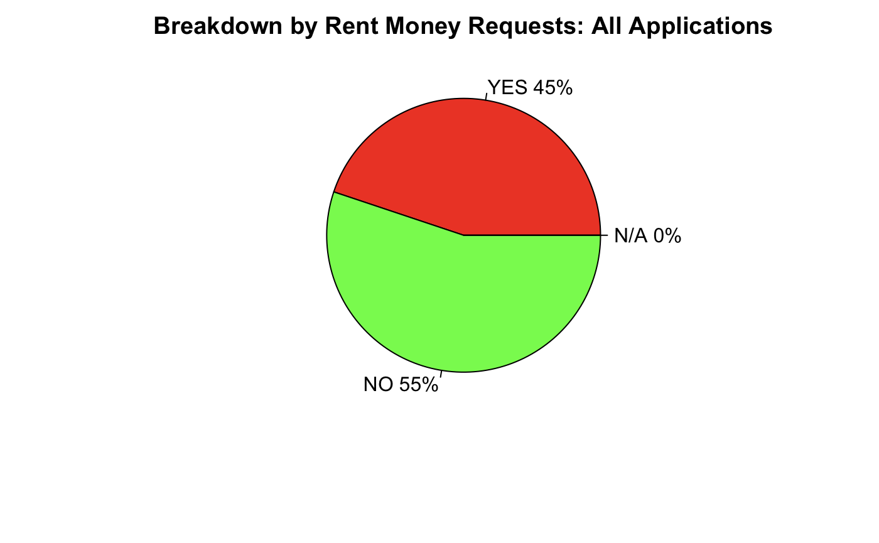

|  |  |  |  |  |
| --- | --- | --- | --- | --- |
| **Requested_Other_Label**  <chr> | **Requested_Other_req_freq**  <int> | **Requested_Other_recom_frq**  <int> |  |  |
| YES | 95 | 91 |  |  |
| NO | 197 | 173 |  |  |
| N/A | 0 | 0 |  |  |

